Creating table for employee salary:

create table emp_salary(

emp_id int primary key,

emp_name varchar(20),

salary int

);

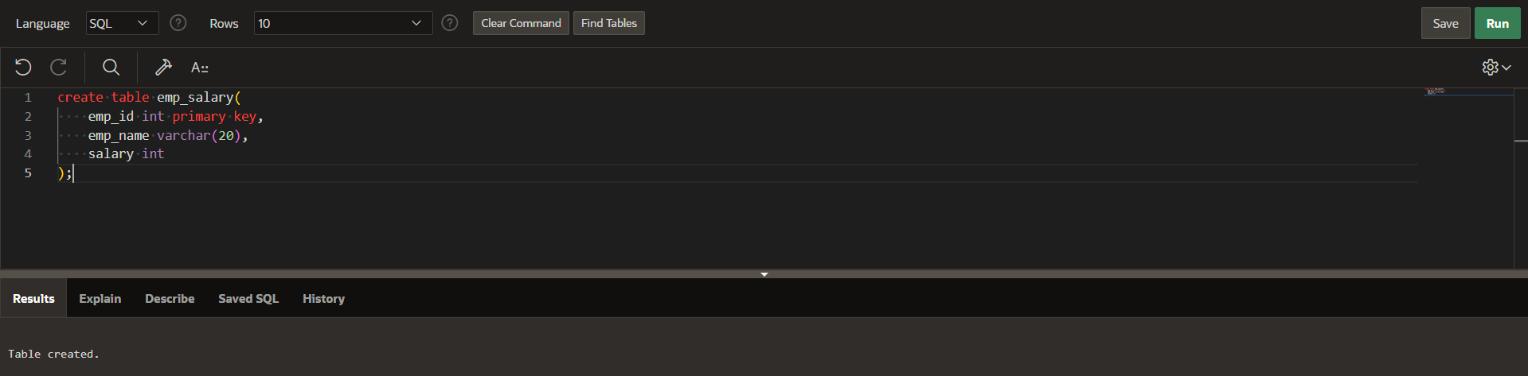

Inserting values in table:

insert into emp_salary

values(1,'rupesh',10000);

insert into emp_salary

values(2,'harshit',20000);

insert into emp_salary

values(3,'uday',30000); 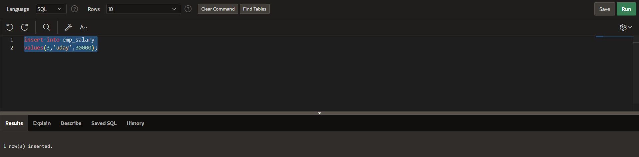

Creating procedure for converting salary into dollars:

CREATE OR REPLACE PROCEDURE get_salary_in_dollars(

p_emp_id IN NUMBER,

p_salary IN OUT NUMBER,

p_dollars out number

)

AS

v_exchange_rate NUMBER := 0.014;

BEGIN

SELECT salary INTO p_salary

FROM emp_salary

WHERE emp_id = p_emp_id;

p_dollars := p_salary * v_exchange_rate;

END; 0

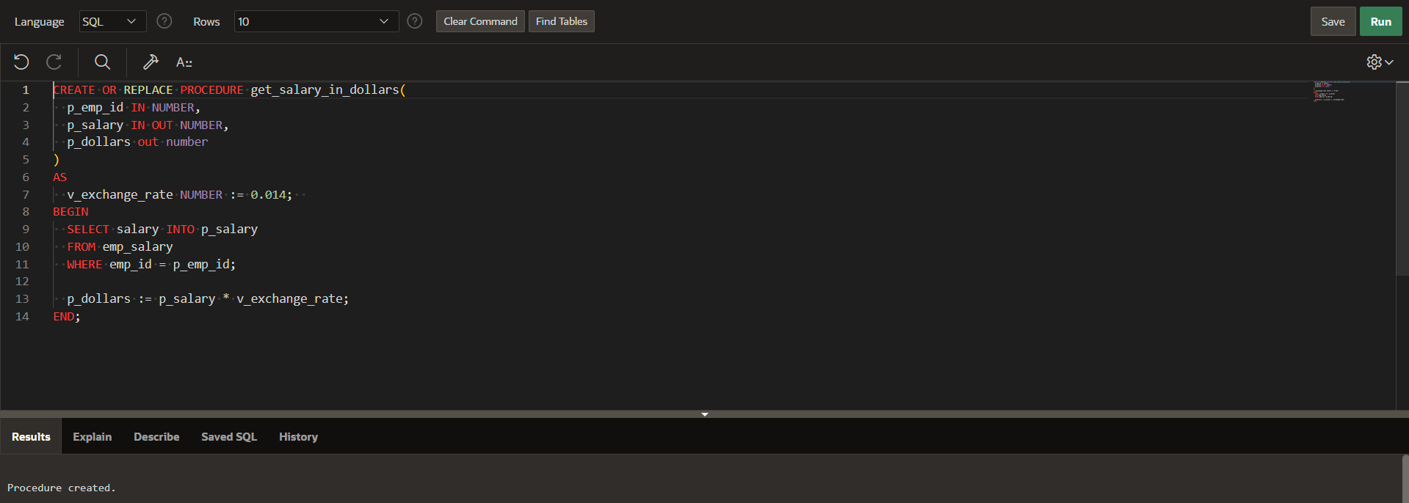

Using procedure in plsql:

DECLARE

v_emp_id NUMBER := 1;

v_salary NUMBER;

v_dollars NUMBER;

BEGIN

get_salary_in_dollars(v_emp_id, v_salary, v_dollars);

DBMS_OUTPUT.PUT_LINE('Original salary: ' || v_salary);

DBMS_OUTPUT.PUT_LINE('Salary in dollars: ' || v_dollars);

END;

